**Name: E. Sai Manoj Mis. No.: 112015044**

**Code:**

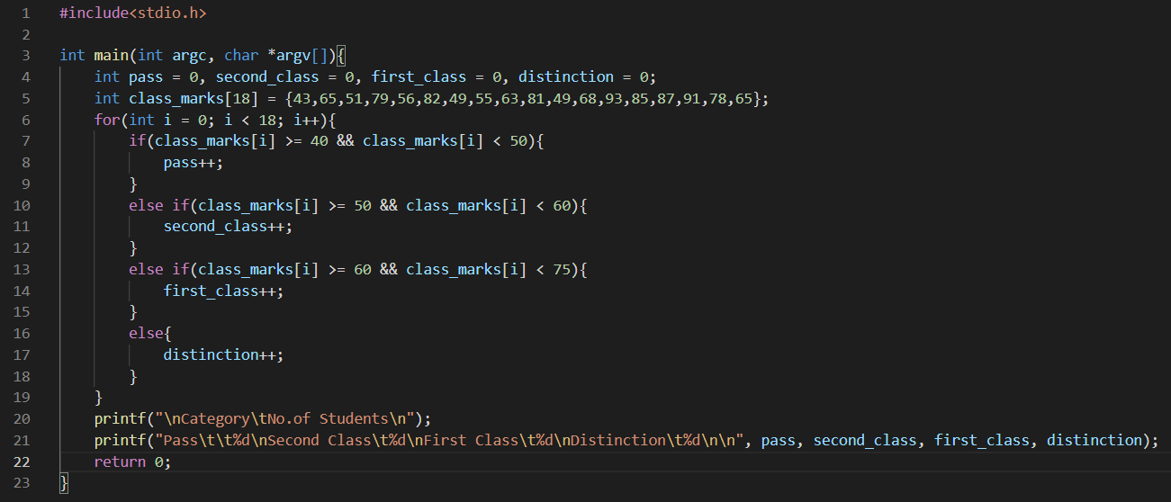

**Output:**

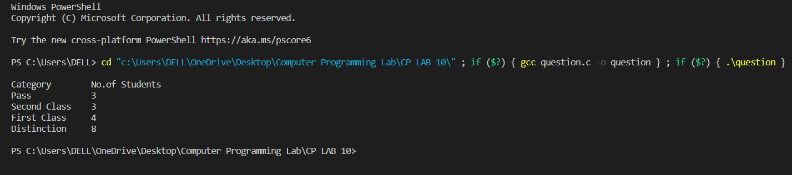

**Code:**

#include<stdio.h>

int main(int argc, char *argv[]){

int pass = 0, second_class = 0, first_class = 0, distinction = 0;

int class_marks[18] = {43,65,51,79,56,82,49,55,63,81,49,68,93,85,87,91,78,65};

for(int i = 0; i < 18; i++){

if(class_marks[i] >= 40 && class_marks[i] < 50){

pass++;

}

else if(class_marks[i] >= 50 && class_marks[i] < 60){

second_class++;

}

else if(class_marks[i] >= 60 && class_marks[i] < 75){

first_class++;

}

else{

distinction++;

}

}

printf("\nCategory\tNo.of Students\n");

printf("Pass\t\t%d\nSecond Class\t%d\nFirst Class\t%d\nDistinction\t%d\n\n", pass, second_class, first_class, distinction);

return 0;

}